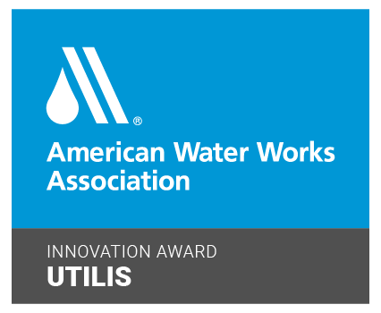

**For Release:**

**Utilis Wins Inaugural AWWA Innovation Award**

**San Diego, CA, June 1, 2021:** Utilis announced today that it is the recipient of the [American Water Works Association](http://www.awwa.org)’s inaugural Innovation Award. With this new award, the American Water Works Association (AWWA) recognized Utilis for fulfilling the vision of the Association’s [Innovation Initiative](https://www.awwa.org/Resources-Tools/Resource-Topics/Innovation). The ongoing initiative is to inspire and implement innovative thinking and best practices to address challenges within the water industry and achieve significant positive results.

Utilis developed technology that lowers the cost of finding potable water leaks with its synthetic aperture radar (SAR) technology. Utilis uses reflected signals from a satellite to detect the underground presence of potable water. A staggering 7200M gallons of water are saved every year through Utilis solutions, with an average of 3.3 leaks found per day at each subscribing utility.

“This technology is a real game changer,” said AWWA Past President Charlie Anderson, of CDM Smith, and a member of the committee deciding the winners. “It can save upfront leak detection costs, find remote subsurface leaks, especially during natural disaster situations where the utility is trying to restore system pressure.”

"We are honored to receive the Innovation Award from the American Water Works Association,” remarked Elly Perets, Utilis CEO. “The AWWA places a high value on innovation because it is the way utilities can address many challenges, including aging infrastructure. Utilis is happy to contribute to the digital transformation of water utilities. Our work protects the world’s most important resource.”

The AWWA is the largest nonprofit, scientific and educational association dedicated to managing and treating water. They provide solutions to improve public health, protect the environment, strengthen the economy and enhance our quality of life. “Working with AWWA is central to the Utilis mission to use SAR analytics to support the earth’s resilience,” Perets said. “Our team continues to innovate. This year we are growing our SAR-based products to support the greater infrastructure industry with soil moisture intelligence.”

***

**ABOUT UTILIS**

Utilis provides data driven solutions for water utilities, government agencies, and the greater infrastructure industry. They use synthetic aperture radar (SAR) data from satellites and turn it into large scale decision support tools. The proprietary algorithms and highly educated staff of scientists and engineers are the key to the company’s mission, to advance planet Earth’s resource resilience through SAR analytics. Successfully commercializing their first product, leak detection in 2016, Utilis projects have resulted in saving more than 7000 million gallons of potable water and 17,000 MWH of energy per year, in support of United Nations Sustainable Development Goals (SDG). Headquartered in Israel, with offices in the United States and United Kingdom, Utilis currently provides innovative data solutions in multiple verticals around the globe. For more information on Utilis and to learn more about their technology visit <https://utiliscorp.com/>

**###**

Media Contact

Karen Dubey

Corporate Marketing Director

marketing@utiliscorp.com

(858) 798-6709