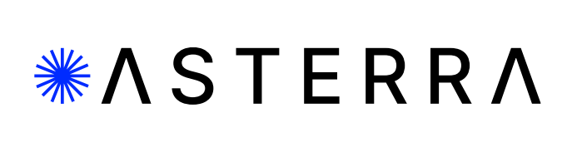

**For Immediate Release:**

**Gulf Coast Water Authority selects ASTERRA EarthWorks to monitor critical levee infrastructure in Texas**

**Proactive infrastructure monitoring mitigates risk while protecting life and environment**

San Diego, CA, January, 30, 2024 – ASTERRA announced that Gulf Coast Water Authority selected their EarthWorks solution to monitor critical levee infrastructure along the Texas gulf coast.

“We are pleased the Texas Gulf Coast Water Authority will use ASTERRA [EarthWorks](https://asterra.io/solutions/earthworks/) as the pro-active solution for [levee system maintenance](https://asterra.io/solutions/earthworks/),” said James D. Perry, executive vice president of ASTERRA. “This step goes a long way toward preventing catastrophic levee failure and protects the safety of those in their communities.”

The gulf coast region relies on a levee system for its 100 miles of canal systems and critical distribution facilities for water for the citizens in the region. The authority was facing numerous challenges, including the high cost of monitoring, inspection, and maintenance of the levee. There were concerns that the failure of this infrastructure could jeopardize the lives and safety of citizens and cause irreparable environmental and financial damage, and this area of the country has suffered from flood and levee breeches in the past.

The Gulf Coast Water Authority chose ASTERRA as part of an ongoing effort to solve an old problem using cutting edge technology, EarthWorks.

EarthWorks is an [infrastructure monitoring](https://asterra.io/solutions/earthworks/) solution that uses satellite radar and ASTERRA’s proprietary algorithm to monitor vast areas of land. It provides an

accurate soil moisture assessment of the levee and critical infrastructure and enables early detection of potential issues and at-risk areas.

ASTERRA became the clear choice because it provides actionable insights over the entire distribution system, enables efficient resource allocation and quick response time, all while reducing operating costs. [EarthWorks](https://asterra.io/solutions/earthworks/) also provides an alert system for high-risk area notifications, risk mitigation, and issue resolution.

***

ASTERRA (formerly Utilis) provides geospatial data-driven platform solutions for water utilities, government agencies, and the greater infrastructure industry in the areas of roads, rails, dams, and mines. ASTERRA services use Polarimetric Synthetic Aperture Radar (PolSAR) data from satellites and use artificial intelligence (AI) to turn this data into large-scale decision support tools. The company’s proprietary algorithms, and highly educated scientists and engineers are the keys to their mission, to become humanity’s eyes on the Earth. Since 2017, ASTERRA solutions have been used in over 64 countries to over 600 customers, verifying over 100,000 leaks, saving over 368 billion gallons of potable water, reducing carbon dioxide emissions by 235,520 metric tons, and saving 920,000 MWH of energy, all in support of United Nations Sustainable Development Goals. ASTERRA is headquartered in Israel with offices in the United States, United Kingdom, and Japan. Their innovative data solutions are used in multiple verticals around the globe. For more information on ASTERRA and to learn more about their technology, visit <https://asterra.io>.

**###**

Media Contact:

Alexa Hess

BPR International

Alexa@bpr.international

(740) 624-2893