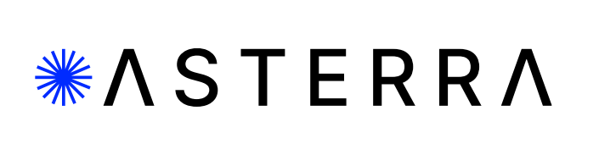

**For Immediate Release**

**ASTERRA surpasses 100,000 water leaks**

**While working across the globe, the 100,000th leak was found in Pennsylvania**

San Diego, September 18, 2023 – A series of subsurface leaks found by Pennsylvania American Water, using ASTERRA satellite leak detection solution Recover*,* represent an important milestone — ASTERRA has now detected over 100,000 water leaks on behalf of customers around the world.

“In honoring this milestone, we recognize global and local efforts coming together in a powerful way,” said Elly Perets, chief executive officer of ASTERRA. “On one level, we celebrate with Pennsylvania American Water because another community is [saving water](https://asterra.io/solutions/recover/), energy and money by using our technology and solutions. But by locating 100,000 leaks — found across more than 64 countries on behalf of over 600 clients — we are also celebrating how the world is adopting ASTERRA’s solutions as we tackle water insecurity and climate change head on.”

According to the World Bank, [32 billion cubic meters of water](https://blogs.worldbank.org/water/what-non-revenue-water-how-can-we-reduce-it-better-water-service) are lost each year around the world. Using L-band Synthetic Aperture Radar combined with proprietary algorithms, ASTERRA has helped utilities recover over 360 billion gallons of water and save over 920,000 MWH of energy since 2016.

Recover is facilitated by the user through ASTERRA’s SaaS platform, [EO Discover](https://asterra.io/platform/). The EO Discover dashboard provides users with all their insights in a single platform, helping utilities prioritize and track their work in the field. It allows leak detection teams to operate more efficiently when exploring the likely leak locations detected by ASTERRA. The platform also provides insights to fulfilling environmental regulations (both ESG and SDG). When utilities have easy-to-use solutions, they are able to spend more time pinpointing and more importantly, repairing the leaks in their system.

“As our team looks to the future, we’re already thinking about the next 100,000 leaks,” said Perets. “We don’t know when or where we will cross those milestones, but we do know this: we’re constantly honing our technology so the next 100,000 will happen much more quickly. Furthermore, many more of the next 100,000 will be wastewater leaks in addition to water leaks. Like the satellites we utilize, the sky is the limit for ASTERRA.”

***

About ASTERRA

ASTERRA (formerly Utilis) provides geospatial, data-driven platform solutions for water utilities, government agencies, and the greater infrastructure industry in the areas of roads, rails, dams, and mines. ASTERRA services use Polarimetric Synthetic Aperture Radar (PolSAR) data from satellites and use artificial intelligence (AI) to turn this data into large-scale decision support tools. The company’s proprietary algorithms, and highly educated scientists and engineers are the keys to their mission, to become humanity’s eyes on the Earth. ASTERRA is headquartered in Israel with offices in the United States, United Kingdom, and Japan. Their innovative data solutions are used in multiple verticals around the globe. For more information on ASTERRA and to learn more about their technology, visit <https://asterra.io>.

###

**Media Contact:**

Susan Fortner

BPR International

susan@bpr.international

(614) 562-0054